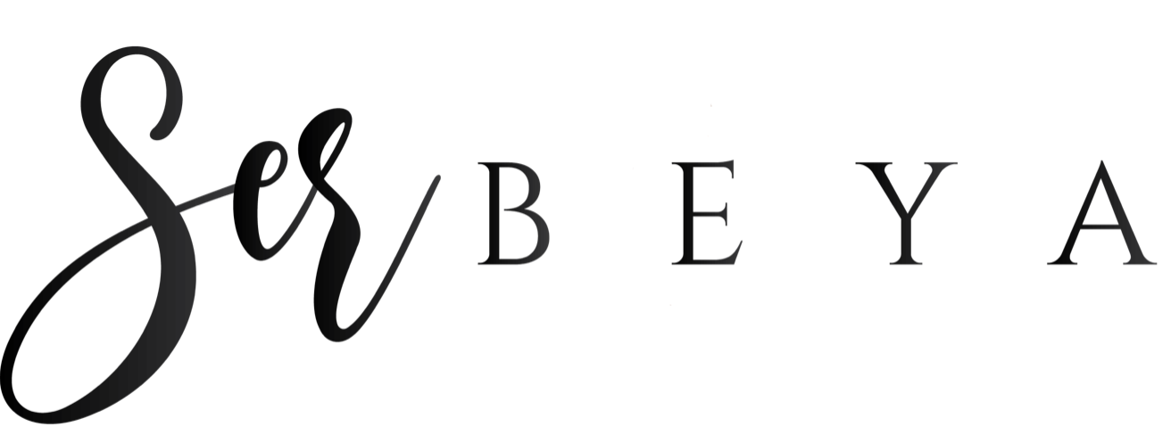
Lash Lift and/or Tint Client Consult Form

Name_____________________________________ Date___________________

Address________________________________________________________________

Phone______________________________ Email______________________________

Have you had a lash lift and/or tint before?_________ Reactions?__________________

Circle any previous discomfort or reactions: skin disorders, eye infections, watery eyes,
Seasonal allergies, allergies to latex/band-aids, eye surgery, inflammation of the skin, hayfever, previous reactions to eye treatments, allergies, bell’s palsy, eye disease

Do you wear contacts?_____ Are you pregnant/nursing?_____ Contraceptive/HRT?_____

Any medications:____________________________________________________________

Have you had lash extensions in the past?__________ If so, why did you stop?_____________

I, ___________________________________, have requested and agreed to the following treatment today without having a patch test done previously. I patch test may indicate my sensitivity or allergy to the products. I take full responsibility and understand the contraindications and aftercare and release the technician, employer and all other parties of their responsibility associated with the supply of the products and services performed. I understand that there is no guarantee of the service, outcome, longevity of the lift and/or tint. All aftercare has been discussed with me prior to the start of the service.

______________________________________________________ Date_______________
Client Signature

______________________________________________________ Date_______________
Technician Signature

_____I give my permission to be photographed before and after the lash lift treatment and for my photos to be used for marketing/social media purposes or any other means without compensation.
_____I do NOT give my permission for my photos to be used for marketing/social media purposes but understand that my photo will still be necessary for portfolio/business purposes only.

For technician use only:

Date________ Lash Health____________ Lash Length__________ Shield Size____________

Tint Color_____________ Tint Time___________ Lash Lift Timing________

Date________ Lash Health____________ Lash Length__________ Shield Size____________

Tint Color_____________ Tint Time___________ Lash Lift Timing________

